SUBJECT: MATHEMATICS(041)
BLUE PRINT

Chapter | MCQ  (1 mark) | VSA  (1 mark) | SA – I  (2 marks) | SA – II  (3 marks) | LA  (4 marks) | Total
Triangles | 1(1) | 2(2) | -- | 3(1) | 4(1)* | 10(5)
Coordinate Geometry | 2(2) | 1(1) | 4(2) | 3(1)* | -- | 10(6)
Introduction to Trigonometry | 1(1) | 1(1) | 2(1)* | 3(1) | 4(1)* | 11(5)
Some Application of Trigonometry | 1(1) | 1(1) | -- | 3(1) | 4(1) | 9(4)
Total | 5(5) | 5(5) | 6(3) | 12(4) | 12(3) | 40(20)

MARKING SCHEME FOR PERIODIC TEST - II

SECTION | MARKS | NO. OF  QUESTIONS | TOTAL
MCQ | 1 | 5 | 05
VSA | 1 | 5 | 05
SA – I | 2 | 3 | 06
SA – II | 3 | 4 | 12
LA | 4 | 3 | 12
GRAND TOTAL |  |  | 40

SUBJECT: MATHEMATICS MAX. MARKS : 40
CLASS : X DURATION: 1½ HRS

General Instructions:
- All questions are compulsory.
- This question paper contains 20 questions divided into four Sections A, B, C and D.
- Section A comprises of 10 questions of 1 mark each. Section B comprises of 3 questions of 2 marks each. Section C comprises of 4 questions of 3 marks each and Section D comprises of 3 questions of 4 marks each.
- There is no overall choice. However, an internal choice has been provided in one question of 2 marks each, one question of 3 marks each and one question of 4 marks each. You have to attempt only one of the alternatives in all such questions.
- Use of Calculators is not permitted

SECTION – A
Questions 1 to 10 carry 1 mark each.
- The angle of elevation of the top of a tower from a point on the ground, which is 20m away from the foot of the tower is 60⁰. Find the height of the tower.
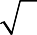
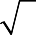
  - 10 3 m (b) 30 3 m (c) 20 3 m (d) none of these
- If cos A = 24 , then the value of sinA is
25

  - 7 25
  - 24
25
  - 1 (d) none of the these

- The distance of A(5, –12) from the origin is
(a) 12 (b) 11 (c) 13 (d) 10

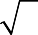
- Find the distance between the points (a cos 35°, 0) and (0, a cos 55°). (a) a (b) a 2 (c) 1 (d) 0
- The areas of two similar triangles are in respectively 9 cm² and 16 cm². The ratio of their corresponding sides is
(a) 2 : 3 (b) 3 : 4 (c) 4 : 3 (d) 4 : 5
- If ΔABC ~ ΔPQR , BC = 8 cm and QR = 6 cm, find the ratio of the areas of Δ ABC and Δ PQR.
- If the distance between the points (8, p) and (4, 3) is 5 then find the value of p.
- An observer on top of a hill measure and angle of depression 60⁰ when looking at a car parked in the valley below. If the car is 55 m is away from the base of the hill, how high is the hill?
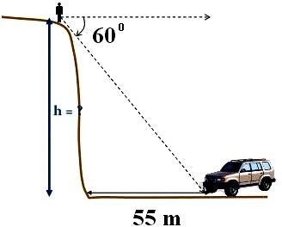

- In triangles ABC and DEF, ∠A = ∠E = 40⁰, AB : ED = AC : EF and ∠F = 65⁰, then find ∠B
1 2sec A

- If sinA =
2 , find the value of 1 + tan 2 A .

SECTION – B
Questions 11 to 13 carry 2 marks each.

- If the point (0, 2) is equidistant from the points (3, k) and (k, 5), find the value of k.

- If secA + tanA = m and secA – tanA = n, find the value of .
mn

OR
If A and B are angles of right angled triangle ABC, right angled at C, prove that Sin²A + Sin²B = 1

- Find the value of k if the points A(2, 3), B(4, k) and C(6, –3) are collinear.

SECTION – C
Questions 14 to 17 carry 3 marks each.

- Ayush starts walking from his house to office. Instead of going to the office directly, he goes to a bank first, from there to his daughter’s school and then reaches the office. What is the extra distance travelled by Ayush in reaching his office? (Assume that all distances covered are in straight lines). If the house is situated at (2, 4), bank at (5, 8), school at (13, 14) and office at (13, 26) and coordinates are in km.

OR

A villager donates his land to Panchayat for Village Hospital, which is in the shape of parallelogram. The three vertices of his land are (3, –4), (–1, –3) and (–6, 2). Find the coordinates of fourth vertex and find the area of land.

- Prove that:
1 −
cos ecA − cot A
1 =
sin A
1 −
sin A
1 .
cos ecA + cot A

- From a point P on the ground the angle of elevation of the top of a 50 m tall building is 30°. A flag is hoisted at the top of the building and the angle of elevation of the top of the flagstaff from P is 45°. Find the length of the flagstaff and the distance of the building from the point P.

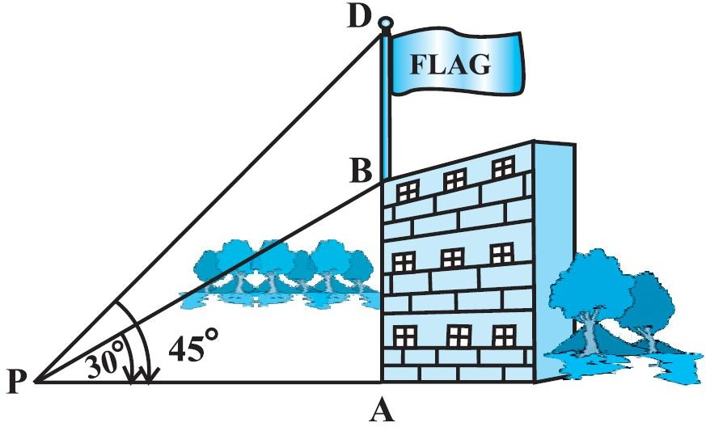

- In the below figure, the line segment XY is parallel to side AC of Δ ABC and it divides the
triangle into two parts of equal areas. Find the ratio AX .
AB
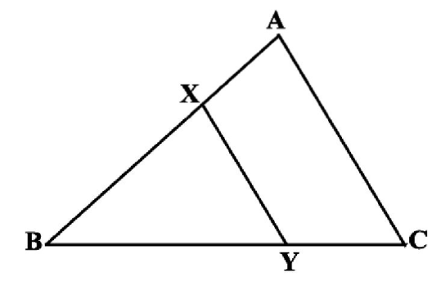

SECTION – D
Questions 18 to 20 carry 4 marks each.
- Prove that “The ratio of the areas of two similar triangles is equal to the square of the ratio of their corresponding sides.”

- Evaluate without using tables:
secθcos ec(900 − θ) − tan θcot(900 − θ) + (sin2 350 + sin2 550 ) tan100 tan 200 tan 450 tan 700 tan 800

OR

If cos ec − sin  = a³ and s ec − cos = b³ , prove that a2b2 (a2 + b2 ) = 1
- A contract was awarded to construct a vertical pillar at a horizontal distance of 100 m from a fixed point. It was decided that angle of elevation of the top of the complete pillar from this point to be 60°. Contractor finished the job by making a pillar such that angle of elevation of its top was 45°.
  - Find the height of the pillar to be increased as per the terms of contract.
  - Contractor demands for the full payment for this work. Is he justified?

