SUBJECT: MATHEMATICS(041)
BLUE PRINT

Chapter | MCQ  (1 mark) | VSA  (1 mark) | SA – I  (2 marks) | SA – II  (3 marks) | LA  (4 marks) | Total
Triangles | 2(2) | 1(1) | -- | 3(1) | 4(1) | 10(5)
Coordinate Geometry | 1(1) | 1(1) | 2(1) | 3(1) | 4(1) | 11(5)
Introduction to Trigonometry | 1(1) | 1(1) | 2(1)* | 3(1)  3(1)* | -- | 10(5)
Some Application of Trigonometry | 1(1) | 2(2) | 2(1) | -- | 4(1)* | 9(5)
Total | 5(5) | 5(5) | 6(3) | 12(4) | 12(3) | 40(20)

MARKING SCHEME FOR PERIODIC TEST - II

SECTION | MARKS | NO. OF  QUESTIONS | TOTAL
MCQ | 1 | 5 | 05
VSA | 1 | 5 | 05
SA – I | 2 | 3 | 06
SA – II | 3 | 4 | 12
LA | 4 | 3 | 12
GRAND TOTAL |  |  | 40

SUBJECT: MATHEMATICS MAX. MARKS : 40
CLASS : X DURATION: 1½ HRS

General Instructions:
- All questions are compulsory.
- This question paper contains 20 questions divided into four Sections A, B, C and D.
- Section A comprises of 10 questions of 1 mark each. Section B comprises of 3 questions of 2 marks each. Section C comprises of 4 questions of 3 marks each and Section D comprises of 3 questions of 4 marks each.
- There is no overall choice. However, an internal choice has been provided in one question of 2 marks each, one question of 3 marks each and one question of 4 marks each. You have to attempt only one of the alternatives in all such questions.
- Use of Calculators is not permitted

SECTION – A
Questions 1 to 10 carry 1 mark each.
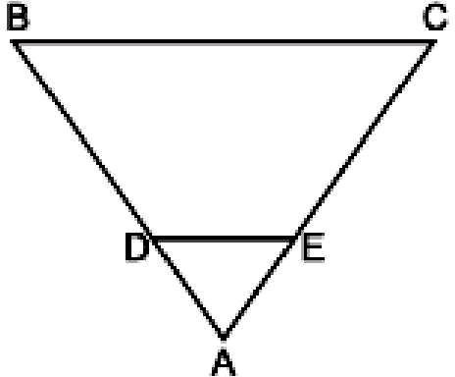
- Areas of two similar triangles are in the ratio 4 : 9. Sides of these triangles are in the ratio (a) 2 : 3 (b) 4 : 9 (c) 81 : 16 (d) 16 : 81
- In the adjoining figure, DE || BC in ΔABC such that BC = 8 cm,
AB = 6 cm and DA = 1.5 cm. Find DE.
  - 2 cm (b) 8 cm (c) 4 cm (d) 6 cm
- Distance of the point (4, a) from x-axis is half its distance from y- axis then a =
(a) 2 (b) 8 (c) 4 (d) 6
- The value of sin60⁰cos30⁰ – cos60⁰sin30⁰ is
  - 1 (b) –1 (c) 0 (d) none of these
- If the altitude of the sun is at 60⁰, then the height of the vertical tower that will cast a shadow of length 30m is
2

  - 30
m (b) 15 m (c) 30
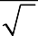
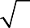3
3
m (d) 15 m

- A girl walks 200 towards East and then she walks 150m towards North. Find the distance of the girl from the starting point.

- If the mid-point of the line segment joining the points P(6, b – 2) and Q(– 2, 4) is (2, – 3), find the value of b.

- A tower is 100 foot.
3
m high. Find the angle of elevation if its top from a point 100 m away from its

- When the length of the shadow of a pole of height 7 m is equal to 7 m then find the elevation of these source of light.
- If tanθ = 15 , find the value of sinθ .
8

SECTION – B
Questions 11 to 13 carry 2 marks each.
- Find the coordinates of the point which divides the line segment joining the points (4, – 3) and (8, 5) in the ratio 3 : 1 internally.

- A boy 1.5 m tall is observing the top of the chimney of height 30 m. The angle of elevation of the top of the chimney from his eyes is 45°. What is the distance of boy from the foot of the chimney?
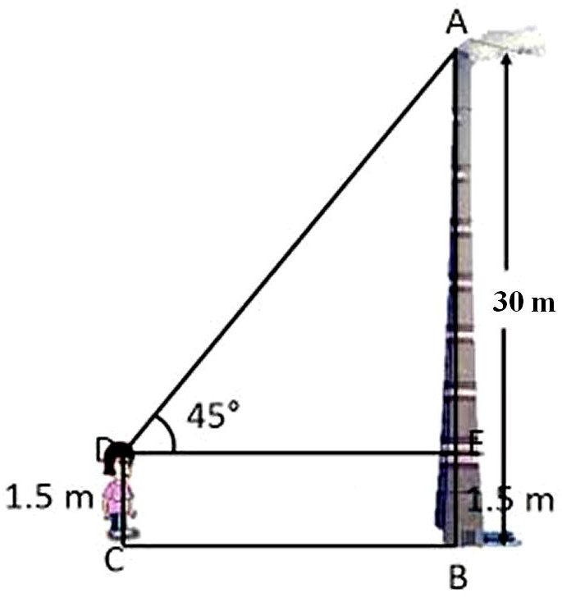
13. Evaluate : 4 cot² 45° – sec² 60° + sin² 60° + cos² 90°.

OR

If cos = 1
2
and
tan  =
- . Find sin( +  )
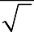
3
where  and  are both acute angles.

SECTION – C
Questions 14 to 17 carry 3 marks each.
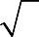3

- If cos (A – B) =
- and sin (A + B) = 1, then find the value of A and B.

OR

Express the trigonometric ratios sin A, sec A and tan A in terms of cot A.
- Nazima is fly fishing in a stream. The tip of her fishing rod is 1.8 m above the surface of the water and the fly at the end of the string rests on the water 3.6 m away and 2.4 m from a point directly under the tip of the rod. Assuming that her string (from the tip of her rod to the fly) is taut, how much string does she have out (see the below figure)? If she pulls in the string at the rate of 5 cm per second, what will be the horizontal distance of the fly from her after 12 seconds?
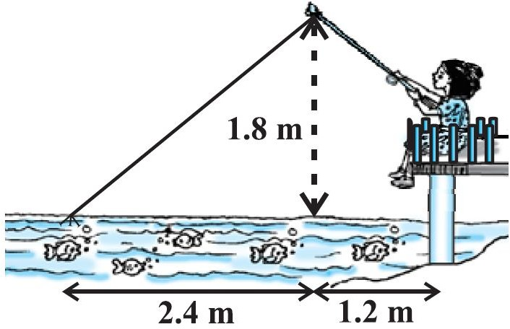

2 sin 680 − 2 cot150 − 3 tan 450 tan 200 tan 400 tan 500 tan 700

- Evaluate:
cos 220
5 tan 750 5

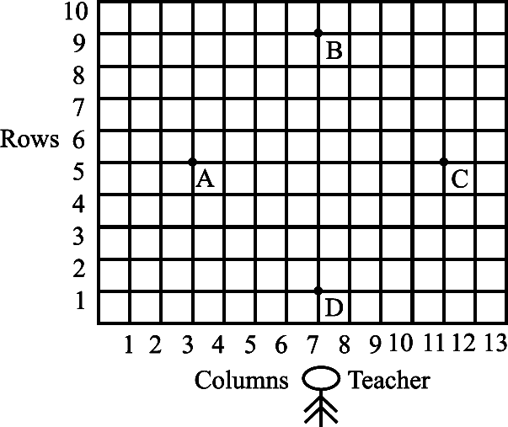
- Students of a school are standing in rows and columns in their playground for a drill practice. A, B, C and D are the positions of four students as shown in below figure. Is it possible to place Jaspal in the drill in such a way that he is equidistant from each of the four students A, B, C and D? If so, what should be his position?

SECTION – D
Questions 18 to 20 carry 4 marks each.

- Prove that, in a right triangle, the square on the hypotenuse is equal to the sum of the squares on the other two sides.

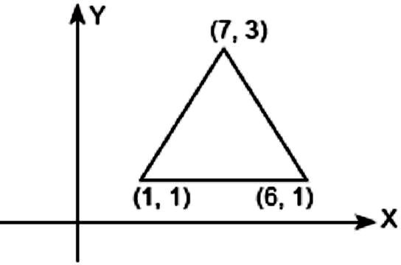
- To raise social awareness about the hazards of smoking a school decided to start “No smoking campaign”. A student is asked to prepare a campaign banner in the shape of a triangle shown in the figure. If cost of 1 cm² of banner is Rs.2, find the cost of the banner.
- A fire in a building B is reported on telephone to two fire stations P and Q, 20 km apart from each other on a straight road. P observes that the fire is at an angle of 60° to the road and Q observes that it is at an angle of 45° to the road. Which station should send its team and how much will this team have to travel?

OR
A highway leads to the foot of 300 m high tower. An observatory is set at the top of the tower. It sees a car moving towards it at an angle of depression of 30°. After 15 seconds angle of depression becomes 60°. Find the distance travelled by the car during this time.

