SET - 03

KENDRIYA VIDYALAYA SANGATHAN
Question Paper
Science
Class – X
Time allowed: 03 Hours ` Maximum Marks: 80

General Instructions:
(i) The question paper comprises two sections, A and B. You are to attempt both the sections.
(ii) All questions are compulsory.
(iii) All questions of Section-A and B are to be attempted separately.
(iv) Question numbers 1 and 2 in Section-A are one mark question. They are to be answered in one word or in one sentence.
(v) Question numbers 3 to 5 in Section- A are two marks questions. These are to be answered in 30 words each.
(vi) Question numbers 6 to 15 in Section-A are three marks questions. These are to be answered in about 50 words each.
(vii) Question numbers 16 to 21 in Section-A are 5 marks questions. These are to be answered in 70 words each.
(viii) Question numbers 22 to 27 in Section- B are based on practical skills. Each question is a two marks question. These are to be answered in brief.

SECTION A
- What is the role of acid in the stomach?
- Arrange the given food chain in proper order of trophic level.
Eagle, plant, snake, frog.
- Why is there a need to harness non-conventional sources of energy? Give two main reasons.
- What is meant by power of lens? What does its sign (+ve or –ve) indicate?
- An element “X” has mass number 35 and the number of neutrons, is 18.Identify the group number and period of “X”.
- Give reasons for the following :
- Why are copper and aluminium metals used as connecting wires?
- Why is tungsten used for filament of electric lamps?
- Why is lead-tin alloy used for fuse wires?
- An element ‘X’ has mass number 35 and number of neutrons 18. Write atomic number and electronic configuration of ‘X’. Also write group number, period and valency of ‘X’.
- Give the diagrammatic outline of breakdown of glucose in absence of oxygen.
OR
List three difference between arteries and veins.
- Where do plants get each of the raw materials required for photosynthesis.
- Define positive geotropism and negative geotropism. Give one example of each.
- In tabular form,list three distinguishing features between acquired traits and the inherited traits.
- What is meant by scattering of light? The sky appears blue and the sun appears reddish at sunrise and sunset. Explain these phenomena with reason.
- The resistance of a wire of 0.01 cm radius is 10Ω. If the resistivity of the material of the wire is 50 x 10⁻⁸ ohm-meter, find the length of wire.
- What is meant by solenoid? How does a current carrying solenoid behave? Give its main use.
- A sanitary worker uses a white chemical having strong smell of chloride gas to disinfect the water tank.
- Identify the chemical compound and write its chemical formula.
- Give chemical equation for its preparation.
- Write its two uses other than disinfection.

- (i) Give a chemical test to distinguish between saturated and unsaturated hydrocarbon.
- Name the products formed when ethane burns in air. Write the balanced chemical equation for the reaction showing the types of energies liberated.
- Why is a reaction between methane and chlorine in the presence of sunlight considered a substitution reaction?
- A. (i) Draw a neat diagram of human brain and
(ii) Label cerebrum and Cerebellum
(iii) Write the functions of the above mentioned parts
B. “Both overproduction and underproduction of growth hormone leads to disorders in the body” Explain.

- A. Draw a longitudinal section of a flower and label the following parts :
- Part that develops into fruit
- Part that produces pollen grain
- Part that transfers male gametes
- Part that is sticky
B. Name the parts labeled A,B,C,d in the diagram given below:

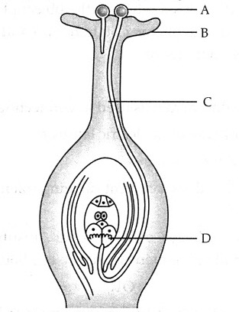
- (i) Define the following terms in the context of spherical mirrors:
- Pole
- Centre of curvature
- Principal axis
- Principal focus
- Draw ray diagrams to show the principal focus of a :
- Concave mirror
- Convex mirror
- Consider the following diagram in which M is a mirror and P is an object and Q is its magnified image formed by the mirror.
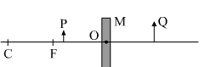
State the type of the mirror M and one characteristic property of the image Q.

- With the help of ciliary muscles the human eye can change its curvature and thus alter the focal length of its lens.
State the changes that occur in the curvature and focal length of the eye lens while viewing: (i) a distance object (ii) nearby object. Explain, why a normal eye is not able to see distinctly the objects placed closer that 25 cm, without putting any strain on the eye.
- Describe the following chemical properties of carbon compounds briefly and give one chemical reaction for each :
- Combustion (ii) Addition (iii) Substitution
(iv) Esterification (v) Oxidation

SECTION B

- What is meant by earthing? Why should electric appliances earthed?
- A student is studying the properties of acetic acid in his school laboratory. List two physical and two chemical properties, which he must observe and note in his record book.
- Draw stomata State its importance.
- Write two precautions to be taken while identifying different parts of anbisexual flower.
- To verify Ohm’s law a circuit diagram was drawn by a student as shown below.
What do K,L,M,N stand for ?
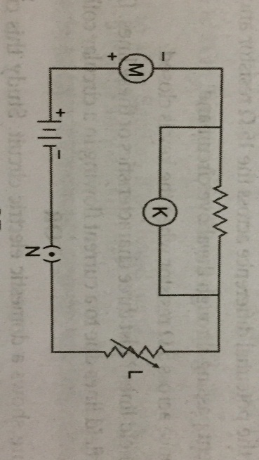
- What precautions should be taken while studying the properties of ethanoic acid?

